CS 255 System Design Document

UML Diagrams

UML Use Case Diagram
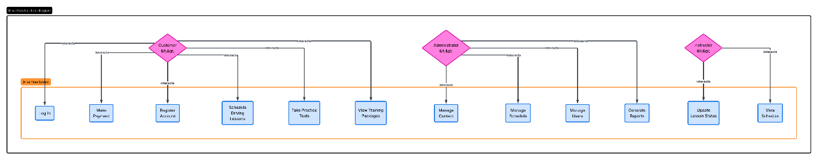

UML Activity Diagrams
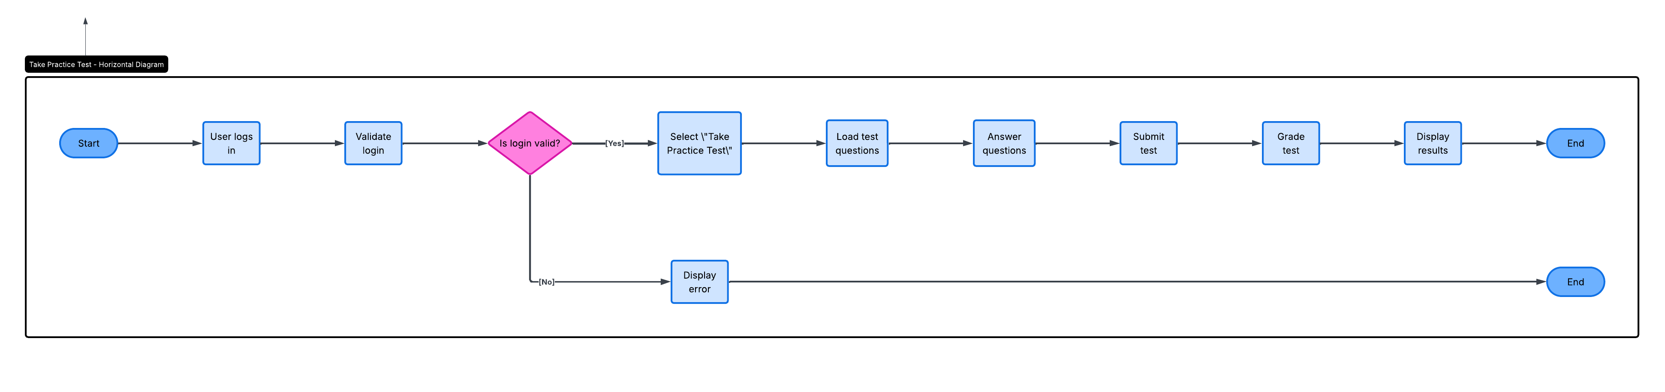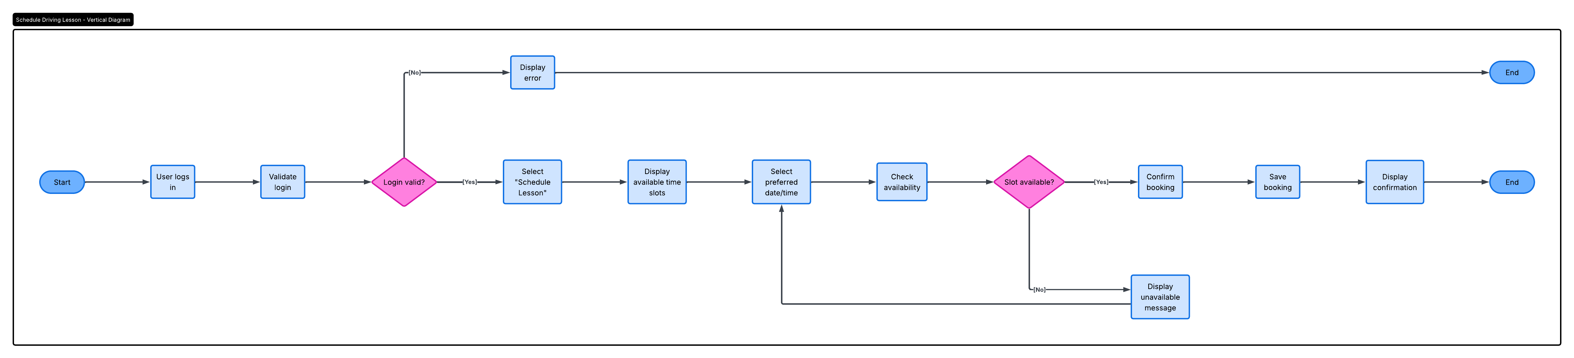

UML Sequence Diagram
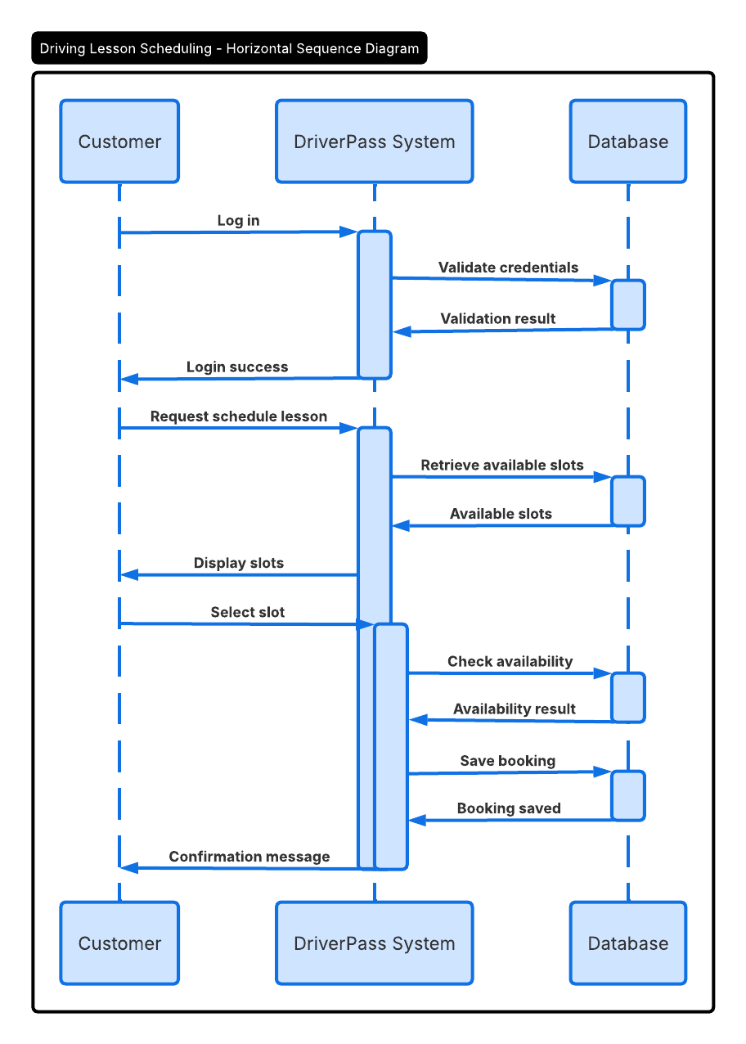]

UML Class Diagram
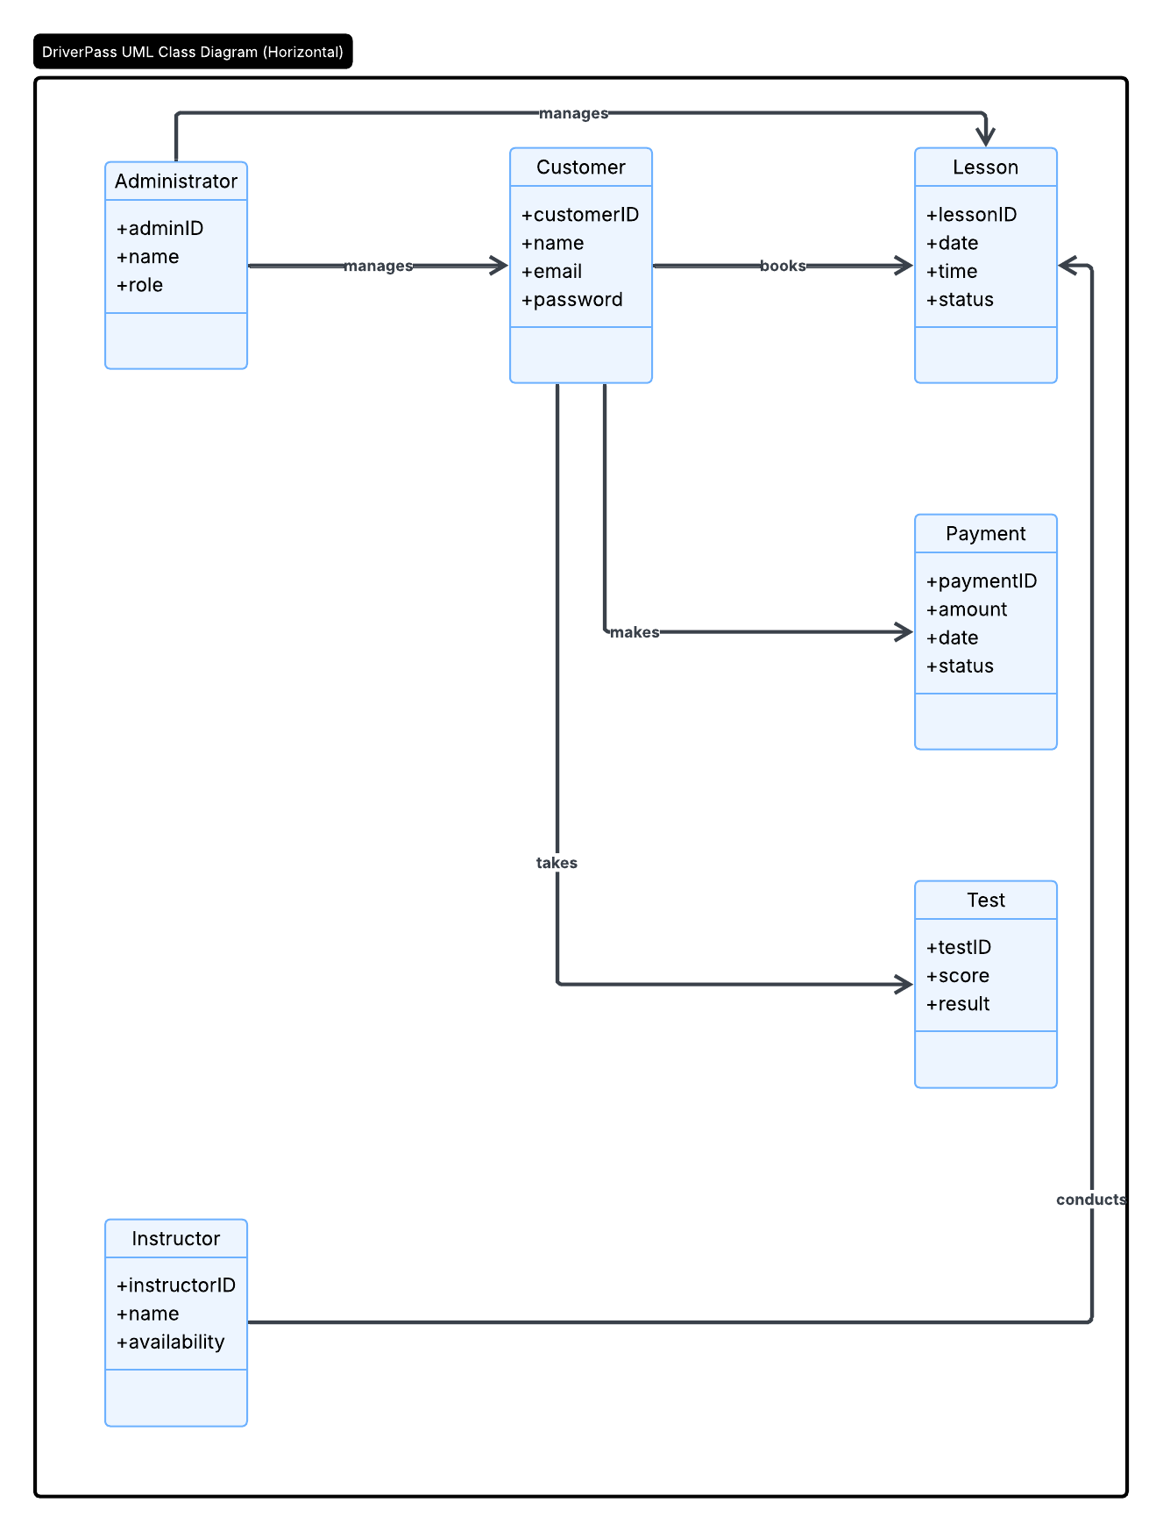

Technical Requirements
The DriverPass system requires a combination of hardware, software, tools, and infrastructure to operate effectively and meet the client’s needs.
Hardware Requirements
The system will require reliable server hardware to host the application and database. Users will access the system using devices such as desktop computers, laptops, tablets, or smartphones. The system should support standard web browsers to ensure accessibility. Additionally, administrative staff may require office workstations with reliable internet connections to manage bookings and user accounts.
Software Requirements
The DriverPass system will operate as a web-based application. It will require a server-side operating system such as Windows Server or Linux. A database management system such as MySQL or PostgreSQL will be used to store user data, schedules, and payment information. The system will also require a web application framework and browser-compatible front-end technologies such as HTML, CSS, and JavaScript.
Tools and Development Environment
Development tools may include integrated development environments (IDEs) such as Visual Studio Code or IntelliJ. The system design was created using Lucidchart as the CASE tool for UML diagrams. Version control systems such as Git may be used to manage code changes and collaboration among developers.
Infrastructure Requirements
The system will require a secure internet connection and may be hosted on a cloud platform such as AWS, Azure, or Google Cloud to ensure scalability and availability. The infrastructure should support data backups, system monitoring, and high uptime. Security measures such as firewalls and encryption protocols must also be in place to protect sensitive user information.

